Abstract Submission Template for IWAPS Conference
Author One ^{1,2}, Author Two ³, Author Three ^{1,*}
¹Department, Institute, City, Country, Postal code;
² Department, Institute, City, Country, Postal code;
³ Department, Institute, City, Country, Postal code.
* email@corrsponding.author

Abstract (100 words)
The abstract should be limited to approximately 100 words. Do not include citations or formula inside the abstract. The abstract should be self-contained (i.e., no numerical references) and substantive in nature, presenting concisely the objectives, methodology used, results obtained, and their significance. A list of up to five keywords should follow, with the keywords separated by commas and ending with a period.

Keywords: IWAPS, Conference, Abstract Submission Template.

Technical Abstract (250~500 words)
The technical abstract is a 250- to 500-word text, containing enough detail to clearly convey the approach and the results of the research. To boost the quality of conference, all abstracts will be reviewed by the Conference Chair/Editor for technical merit and suitability of content. Accepted abstract will be printed for distribution at the meeting.
Figures are highly encouraged in technical abstract.
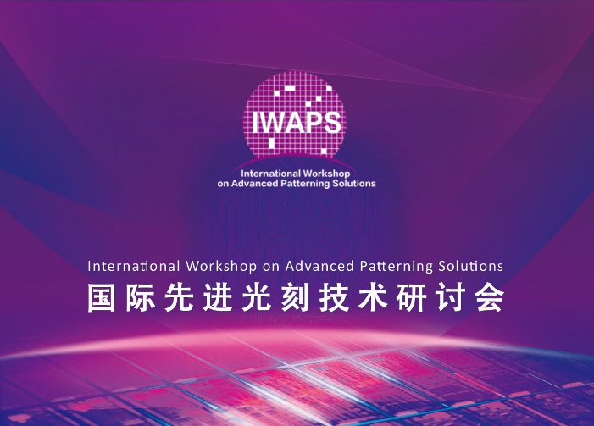
Fig. 1. IWAPS.

Topic Scope | 1. DUV or EUV Process  2. Computational Lithography or DTCO  3. Material  4. Mask  5. Metrology and inspection  6. New patterning solutions  7. Lithography equipment  8. Others (other lithography technologies and problems)
Oral or Poster Prefer: | 1. Oral only  2. Poster only  3. No prefer
Recommend Speaker | Name:  Job Title:  Telephone:  Wechat:  Email:
Recommend Speaker’s biography | One example template:  Dr. (Mr./Ms.) ABC is the Manager in the lithography department at Best company. He graduated from B University with a Bachelor/Master degree in 2000. He/she joined H University and received the PhD degree in 2005. Then he/she joined Best company as the engineer, senior engineer in 2010 and manager of lithography department in 2015. His research interests includes lithography process, OPC, material development, computational lithography. He/she has published XX papers and patents, and has received XXX awards.  (More examples could be found in some journals, such as Journal of Microelectronic Manufacturing, JM3, and so on.)
Speaker’s photo | (see the website for reference)

